**Name: Session:**

**Programming I**

**Lab Exercise 10.2.2023**

For each of these problems, you are to submit your documented source code.

1. Write functions

def sphereVolume(r):

def sphereSurface(r):

def cylinderVolume(r, h):

def cylinderSurface(r, h):

def coneVolume(r, h):

def coneSurface(r, h):

that compute the volume and surface area of a sphere with radius r, a cylinder with a

circular base with radius r and height h, and a cone with a circular base with radius r

and height h. Then write a program that prompts the user for the values of r and h,

calls the six functions, and prints the results.

1. Write a graphical application that displays a checkerboard with 64 squares, alternating white and black.

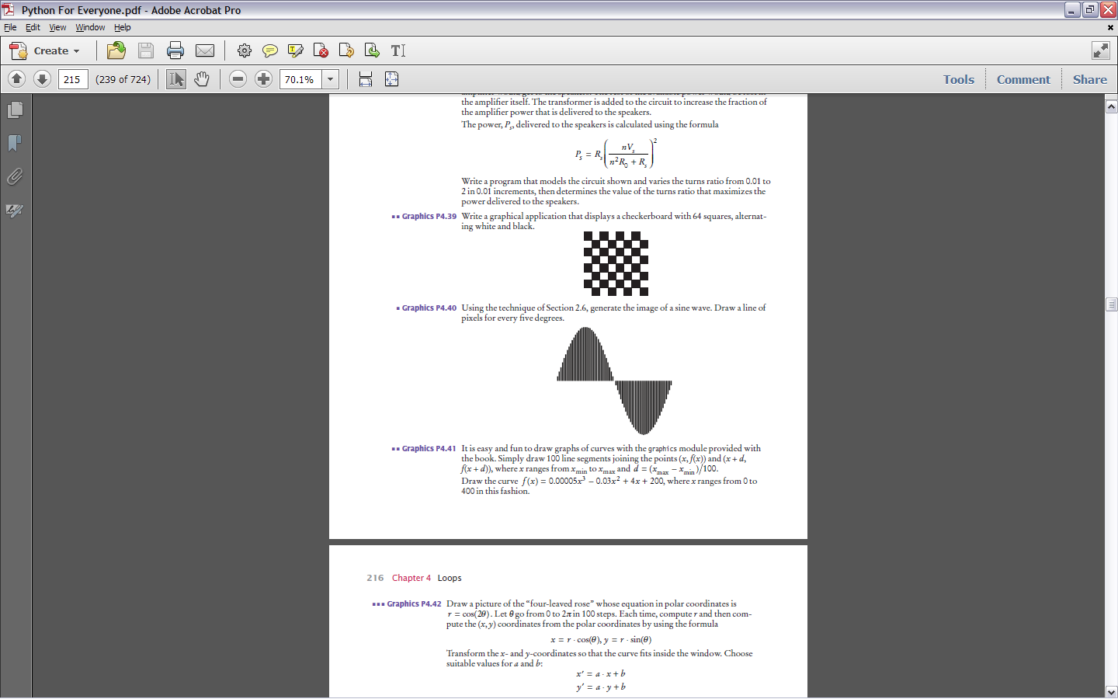

1. Write a function getTimeName(hours, minutes) that returns the English name for a point in time, such as "ten minutes past two", "half past three", "a quarter to four", or "five o'clock". Assume that hours is between 1 and 12.
2. Write a function that transforms numbers 1, 2, 3, …, 12 into the corresponding month names January, February, March, …, December. Also write some code to test your function.

**When you complete these programs, submit your documented source code.**